LAB TASK 1 (A)
NAME : ABDUL RAHEEM
ROLL NO : 041
AI MILESTONES TIMELINE
The following timeline shows important AI milestones in chronological order. It includes an AI Winter period and a modern compute/data milestone.
YEAR / PERIOD | AI MILESTONE | SIGNIFICANCE | SOURCE
1950 | Turing Test | Alan Turing proposed a test to see whether a machine could show intelligent behavior similar to a human. | Alan Turing, Computing Machinery and Intelligence
1956 | Dartmouth Conference | The Dartmouth Conference is widely recognized as an important starting point for AI as a scientific field of study. | Dartmouth College
1966 | ELIZA | ELIZA was one of the first programs capable of conducting dialogue with humans through text input. | MIT Press / Joseph Weizenbaum
1974–1980 | AI Winter 1 | AI experienced a lack of funding and interest because progress in the field was slower than expected. | Encyclopaedia Britannica
1997 | Deep Blue beats Kasparov | IBM's Deep Blue defeated Garry Kasparov in chess and demonstrated the ability of computers to solve complex problems. | IBM
2012 | AlexNet | AlexNet performed very well in image recognition and helped increase interest in deep learning. | NeurIPS / ImageNet
2017 | Transformer Architecture | The Transformer architecture improved computer language processing and became widely used in modern AI systems. | Google Research, Attention Is All You Need
2020s | Modern Compute and Data | Powerful GPUs, large datasets, and greater computing resources contributed to advances in modern generative AI models. | Stanford AI Index

Source Links
1. Turing Test — Alan Turing, Computing Machinery and Intelligence: https://academic.oup.com/mind/article/LIX/236/433/986238
2. Dartmouth Conference — Dartmouth College: https://home.dartmouth.edu/about/artificial-intelligence-ai-coined-dartmouth
3. ELIZA — MIT Press / Joseph Weizenbaum: https://direct.mit.edu/books/edited-volume/5003/chapter/2657050/ELIZA-A-Computer-Program-for-the-Study-of-Natural
4. AI Winter 1 — Encyclopaedia Britannica: https://www.britannica.com/technology/artificial-intelligence
5. Deep Blue beats Kasparov — IBM: https://www.ibm.com/history/deep-blue
6. AlexNet — NeurIPS / ImageNet: https://papers.nips.cc/paper_files/paper/2012/hash/c399862d3b9d6b76c8436e924a68c45b-Abstract.html
7. Transformer Architecture — Google Research, Attention Is All You Need: https://research.google/pubs/attention-is-all-you-need/
8. Modern Compute and Data — Stanford AI Index: https://hai.stanford.edu/ai-index
Conclusion: These milestones show how AI developed from early ideas and simple programs into modern systems supported by powerful computing and large amounts of data.

LAB TASK 1 (B)

Rule-Based Program
The following screenshots show the code written and executed in Visual Studio Code. The previously typed code has been removed from this document and replaced with the actual screenshots of the program and its output.

Code and Program Output
Screenshot 1
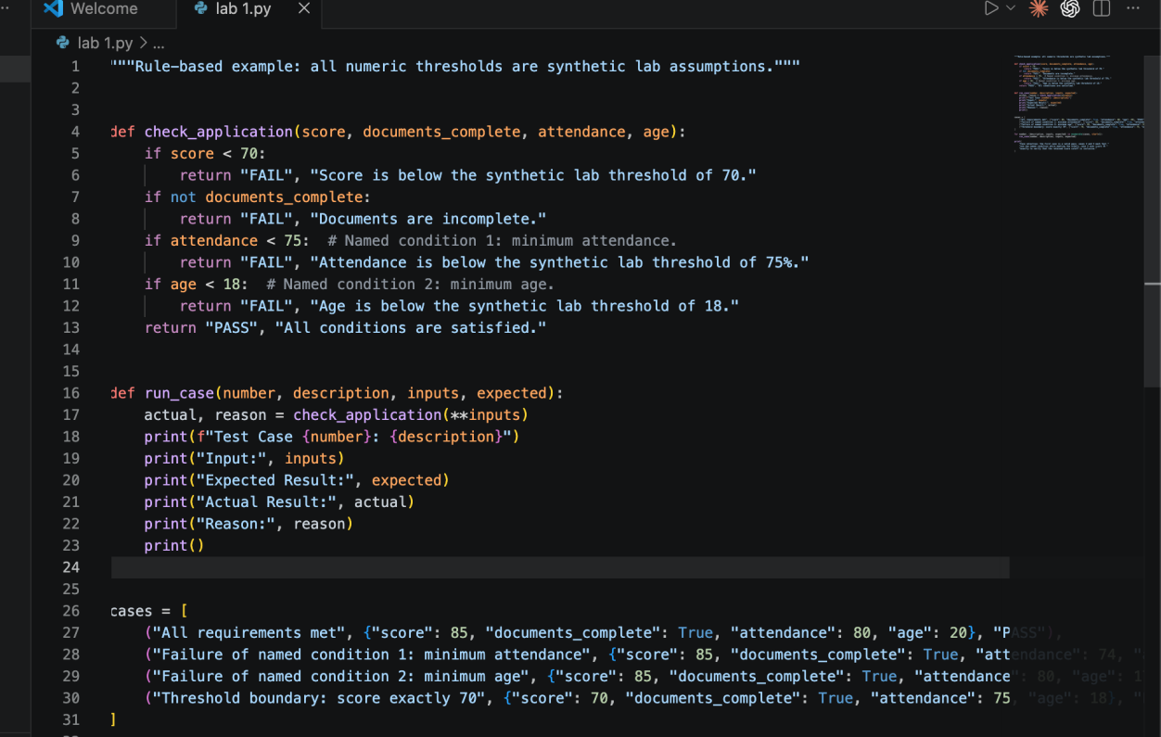
Screenshot 2
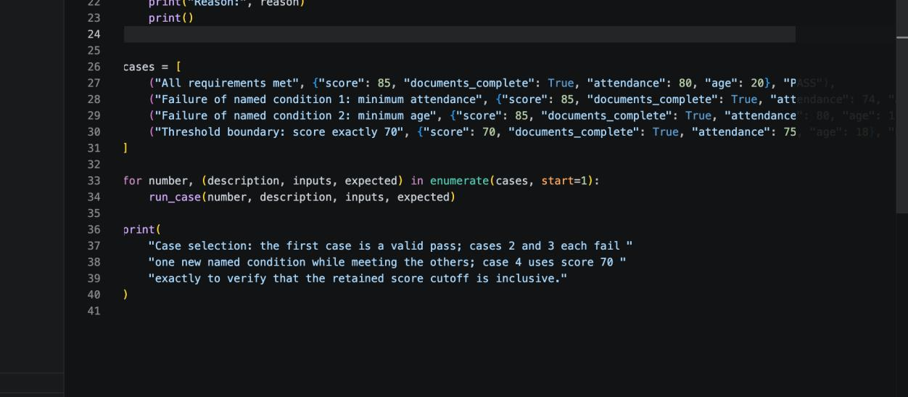
Screenshot 3
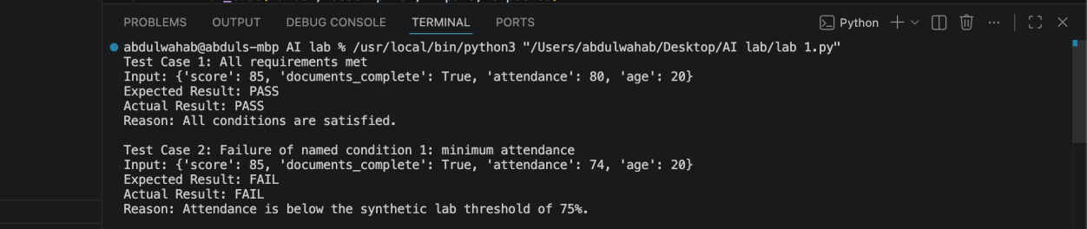
Screenshot 4
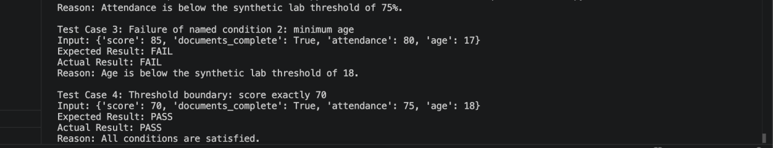

Issue in This Program
I was able to write and understand the code up to the main rule-based conditions by myself. However, I faced difficulty when I reached the test cases and the part where the program had to test multiple cases and display the expected result, actual result, and reason. I did not fully understand how to organize the test cases and how to run them using the functions provided in the program. Therefore, I used AI assistance for the test-case section after the point where I became confused. This was the main issue I faced while completing the program. I am including this issue honestly to show which part of the program I understood independently and where I needed assistance.

What I Understood
I understood the basic rule-based conditions, including the score condition, document completeness condition, minimum attendance condition, and minimum age condition.

Where I Needed Help
I needed help with organizing the test cases, passing the input values to the function, checking the expected and actual results, and using the loop to run all four cases.

LAB TASK 1 (C)

Human vs AI Writing Analysis
Analysis of Linguistic Features Supporting a Human-Written Verdict

1. Sentence Length & Structure
Average sentence length here is closer to human writing norms, aligning with the human average of 23.2 words rather than the AI average of 29.2, which supports the human-written verdict.
Presence of very-short, punchy sentences where shorter units appear to punctuate ideas, aligning with the human tendency to include concise statements.
Longer, nuanced sentence structures with embedded clauses that resemble human reasoning rather than the more formulaic, extended hedging typical of AI text.

2. Function Words & Vocabulary
higher function-word usage is evident, consistent with human-style prose that relies on articles and prepositions to shape meaning rather than dense content words.
Higher function-word ratio consistent with human prose (function words ~0.40, higher than AI), indicating typical human sentence construction and flow.
Shorter mean word length relative to AI (human mean around 5.24 characters vs AI 5.86), reflected in straightforward vocabulary rather than overly long terms.

3. Discourse Flow & Connectives
Longer pauses between ideas and a natural flow of explanation resemble human explanatory writing, with occasional hedges and clarifications rather than relentless, evenly distributed technical phrasing.
Human-skewed connectives and sentence starters appear in natural, varied placements rather than formulaic hedging, reinforcing human-like discourse flow.
Use of natural, human-oriented connective and sentence-starter choices with a mixture of discourse markers that align with human writing (e.g., Consequently, Therefore, thus appear less aggressively than AI hedging).

4. Repetition Patterns
- Higher self-repetition / repeated phrases pattern typical of human writing (3-gram repetition rate higher than AI), evidenced by recurring evaluative phrases across the excerpt.

5. Key Excerpts from the Analysed Text
The following passages were examined for the linguistic features listed above

Turing Test & Conversational Behaviour
“A conversational test verifies whether an AI can produce conversational behaviors that can be human-like.”
“In the year 1950, Alan Turing proposed the Imitation Game in his Computing Machinery and Intelligence Paper as a means of discussion on whether machines can have human-like behaviours.”
“The test primarily observes conversational behavior, which includes how naturally a system produces response and interacts.”
“It means that the system can communicate effectively without being able to understand a problem,
reason about it and perform real-life tasks.”

Scholarship Eligibility Case
“It involves the AI being provided with several scholarship applications with GPAs, incomes, ages,
and other necessary documents, and its conclusions on eligibility of each application being compared
to the correct answers.”
“The scholarship case has demonstrated why the ability to perform a task reliably is needed too.”
“The conversational approach will fail to verify whether the AI can check GPA conditions, income
conditions, necessary documents, and other conditions for eligibility.”
“In a scholarship that has a GPA condition of 3.0, an AI system may confidently declare that:”
“It will be an excellent response that seems fluent and logical, but the conclusion reached by the AI
system is incorrect since 2.5 is less than the required GPA of 3.0.”
“The test must have some normal cases as well as some boundary cases, like when the GPA is just
at the required level.”

Bibliographic Reference
“Turing, A. M. (1950). Computing Machinery and Intelligence. Mind, Volume LIX, Issue 236, pages
433–460.”
The sentence is highly repetitive in format (author, year, title, venue, pages), a pattern humans use in citation-style writing to ensure clarity. There is a clear, non-narrative reference pattern (bibliographic metadata) that matches human scholarly conventions rather than AI-generated discourse.

6. Conclusion
The combination of human-typical sentence lengths, elevated function-word ratios, natural discourse markers, shorter average word lengths, and higher self-repetition rates collectively supports a human-written verdict for the analysed text. The presence of both conversational Turing-test discussion and a concrete scholarship-eligibility scenario further illustrates the limitations of purely conversational evaluation of AI systems.

